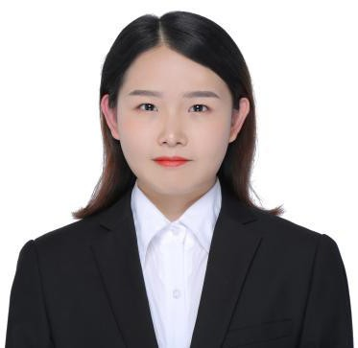
JINGSHA JIANG
Mobile : 18728348973
E-mail ：18728348973@163.com Address：Chengdu, Sichuan, China

Personal Information

Nationality: Chinese Gender：Female Date of Birth：1998.04

Education Background
2017.9-2021.6 Chengdu Medical College Major：Pharmacy（Bachelor）

Work / Intership Experience
- 2018.01 – PRESENT Future Group | Medical Interpreter
Provide over-the-phone consecutive interpreting between English-speaking clients and their Mandarin speaking customers.

- 2021.11 - 2022.05 Limewing Talents | Reseacher
Limewing Talents is a UK based company and we mainly help international schools in China hire foreign teachers as arecruiter
- 2021.5 - 2021.11 AGS | Headhunting Intern
|6 months
AGS is a US-funded headhunting company. I mainly use online and offline recruitment channels to assist my colleagues in the recruitment of Chanel in Chengdu and Cadillac's new energy electric vehicles nationwide.
- 2020.11-2021.4 GSK | Vaccine Sales Intern
|5 months
Maintain communication with customers, promote vaccines, participate inweekly meetings and training.
- 2020.11-2021.7 i2 | Foreign teacher assistant Intern
|9 months
Assist foreign teachers in teaching, including classroom translation, academic feedback, communication with parents, etc.
- 2019.7-2019.12 Roche | Administrative Intern
|6 months
summarize sales data, analyze and report department financial data, collect summit

customer information, assist monthly meetings, participate in team internal training, and follow up intern interviews.
- 2018.9–2019.7 New Oriental | English Teaching Assistant Intern
|11 months
Responsible for teaching assistant's class schedule and performance evaluation, salary calculation and attendance management, handling emergencies, participating in review summary and asistant training.

Volunteer experience
2018.7 | Suining City's Anju District Sanjia Town Primary School Teaching Support

2018.1 - 2018.12 | Raise 12,000 yuan to help children from poor families with team

Certificate
- National inspirational scholarship
- school-level third-class academic scholarship
- CET-6
- computer second-level certificate (MS Office)
- SYB undergraduate entrepreneurship training
- PTE ( 61 score )

